TITLE | Implementation of A* Algorithm.
PROBLEM STATEMENT / DEFINITION | Write a program in C++ / Python to implement A* Algorithm for Arad Problem.
OBJECTIVE | - Understanding difference in informed and uninformed search techniques.  - To study the applications of the informed search methods.  - Basic understanding of adjacency lists  - To study applications of A* algorithms
S/W PACKAGES AND  HARDWARE APPARATUS USED | - Operating System : Latest version of 64 –Bit operating systems open source Fedora 20 or higher equivalent or Windows 8 with Multicore CPU equivalent to Intel i5 / 7 generation onwards  - Debain based OS ( Ubuntu 13.04 ) , g ++ , Python 2.7  - Programming Tools : Latest 64 –Bit Programming languages such as Microsoft Visual Studio ( ver. 12 or Higher ) or equivalent open source , Eclipse / QT 64 –Bit platform / IDLE editor  - Networked computer with internet access  - Valid e–mail account  - Wireshark 5.0 – Ethereal software / LanExplorer  - 32 / 64 –bit LATXT
REFERENCES | EBook : http://www.cin.ufpe.br/~tfl2/artificial-intelligence-modern-approach.9780131038059.25368.pdf  Artificial Intelligence- Building intelligent system by Parag Kulkarni and Prachi Joshi
STEPS | Refer to theory, algorithm, test input, test output
INSTRUCTIONS FOR  WRITING JOURNAL | - Date  - Assignment no.  - Problem definition  - Learning objective  - Learning outcome  - Related Mathematics  - State transition diagram  - Concepts related Theory  - Program code with proper documentation.  - Output of program.  - Conclusion and applications (the verification and testing of outcomes)

Assignment No. 3

- Problem Statement
Implement A* approach for any suitable application.

- Prerequisites
- Object oriented programming features.
- Understanding of Best first search method
- File handling

- Learning Objectives
- Understanding difference in informed and uninformed search techniques.
- To study the applications of the informed search methods.
- Basic understanding of adjacency lists
- To study applications of A* algorithms

- Learning Outcome
- Ability to understand different types of informed search techniques
- Ability to apply informed search methods.
- The ability to focus on the Admissible part of Best first search

- Related Mathematics
Let S be the system set for above mentioned problem definition ,
where,
S = {s , e , X , Y Fs , Sc , F, List}
where,
s = start state ={ Arad}
X = Input Set
= { x1 , x2 ... xn }s
where,
x1 = no of nodes in graph
x2 = no of edges in graph
x3 = acual distances between nodes
x4 = heuristic values of distances between nodes (estimated distances)
x5 = names of cities (or nodes)
Y=Output={< x1’,x2’,x3’….xk’>}
Final path taken of all cities from source to destination with distance
For all xi’belong to I1 | 1<=i<=n
Where x1’= Arad & xk’= Busharest
Also for all 1<=i,j<=n , i != j
i.e xi’ !=xj’ for 1<=k<=n
Fm = { f1.f2.. fn}
f1 = function to insert into linked list
f2 = function to display from linked list
f3 = function to insert into priority queue
f4 = function to display from priority queue
Function F={cost}
Min {f(x)}
Where f(x)=g(x)+h(x).
g(x)= min( x,i)
I belongs to[a…z] where (adj([a…z], x)
h(x)= {[p..q]}
j belongs to [p,q]
DD = deterministic data
1) Actual distances between cities
2) Heuristic values of distances
3) No. Of nodes and edges
NDD = Non deterministic data
1) total shortest path from source to destination
Sc = Success case
1) Successfully finds shortest path from source to destination
2) No redundancy of visited nodes
Fc= failure case
- If heuristic distance is over or under estimated , the calculated distance may not be accurate

- Algorithm:
Step 1:
Start – OPEN = nodes on frontier. CLOSED = expanded nodes.
OPEN = {<S,Nil>}
OPEN = nodes on frontier. CLOSED = expanded nodes.
OPEN = {<S,Nil>}
Step 2 :
while OPEN is not empty.
Remove from OPEN the node <N,P>, with minimum f(n).
place <n,p> on CLOSED.
Step 3:
if n is a goal node,
return path (p)
Step 4:
for each edge connecting n & m with cost c,
Step 5:
if <m, q> is on CLOSED and {p|e} is cheaper than qC LOSED,
then remove n from C|e}> on OPEN
put <m,{p /e}> on OPEN
Step 6:
else if <m,q> is on OPEN & {P /e }is cheaper then q,
then replace q with {p|e}
else if m is not on OPEN
then put <m,{p|e}> on OPEN
return failure .

Function Dependency Diagram:

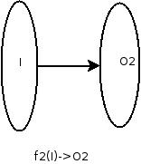
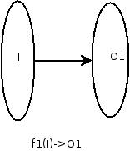

- Concepts related Theory
Search methods
Properties of search methods:
- Completeness. – Does the method find the solution if it exists? •
- Optimality. – Is the solution returned by the algorithm optimal? Does it give a minimum length path?
- Space and time complexity. – How much time it takes to find the solution? – How much memory is needed to do this?

Graph Theory:
In mathematics and computer science, graph theory is the study of graphs, which are mathematical structures used to model pairwise relations between objects. A "graph" in this context is made up of "vertices" or "nodes" and lines called edges that connect them. A graph may be undirected, meaning that there is no distinction between the two vertices associated with each edge, or its edges may be directed from one vertex to another. Graphs are one of the prime objects of study in discrete mathematics.
In the most common sense of the term,a graph is an ordered pair G=(V,E) comprising a set V of vertices or nodes together with a set E of edges or lines, which are 2-element subsets of V(i.e., an edge is related with two vertices, and the relation is represented as an unordered pair of the vertices with respect to the particular edge). To avoid ambiguity, this type of graph may be described precisely as undirected and simple.

Informed Search
We have seen that uninformed search methods that systematically explore the state space and find the goal. They are inefficient in most cases. Informed search methods use problem specific knowledge, and may be more efficient. At the heart of such algorithms there is the concept of a heuristic function.

Heuristics
Heuristic means “rule of thumb”. To quote Judea Pearl, “Heuristics are criteria, methods or principles for deciding which among several alternative courses of action promises to be the most effective in order to achieve some goal”. In heuristic search or informed search, heuristics are used to identify the most promising search path.

Example of Heuristic Function
A heuristic function at a node n is an estimate of the optimum cost from the current node to a goal. It is denoted by h(n).
h(n) = estimated cost of the cheapest path from node n to a goal node
Example 1: We want a path from Kolkata to Guwahati
Heuristic for Guwahati may be straight-line distance between Kolkata and Guwahati
h(Kolkata) = euclideanDistance(Kolkata, Guwahati)

2 | 8 | 3
1 | 6 | 4
7 |  | 5
Initial State
1 | 2 | 3
8 |  | 4
7 | 6 | 5
Goal State
The first picture shows the current state n, and the second picture the goal state.
h(n) = 5 because the tiles 2, 8, 1, 6 and 7 are out of place.

Manhattan Distance Heuristic: Another heuristic for 8-puzzle is the Manhattan distance heuristic. This heuristic sums the distance that the tiles are out of place. The distance of a tile is measured by the sum of the differences in the x-positions and the y-positions. For the above example, using the Manhattan distance heuristic,
h(n) = 1 + 1 + 0 + 0 + 0 + 1 + 1 + 2 = 6

Different methods in heuristics/informed search
- Best-First Search
  - greedy search
  - A*search Algorithm
- Local Search
  - Hill-climbing
  - Simulated annealing
  - Genetic algorithms
  - Local search in continuous spaces
Best First Search
- It is combination of BFS and DFS. The positive point of DFS is that the goal can be reached without any need to computer all the states whereas BFS, does not get halted or trapped in dead paths.
- Best First Search allows switching of paths and thus gets benefit of both.
- In Best first search, if the selected node is not found promising compared to previous node than backtracking is allowed.
- At each step, we select most promising node by applying heuristic function to each of them.
- We expand the chosen node by using rules to generate successor.
- If one of them is a solution we quit. If not all nodes are added to the set of nodes generated so far. Again most promising node is selected and the process continues.
- Uniform Cost Search is a special case of the best first search algorithm. The algorithm maintains a priority queue of nodes to be explored. A cost function f(n) is applied to each node. The nodes are put in OPEN in the order of their f values. Nodes with smaller f(n) values are expanded early.

Example:
Let us take an example of travel from Arad to Bucharest. The available routes are shown in below diagram:

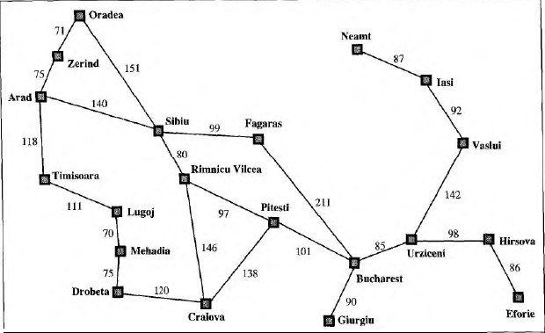

The Best First Search uses the greedy approach; it is also referred to as greedy search. It will opt for the below shown path based on the best available option:
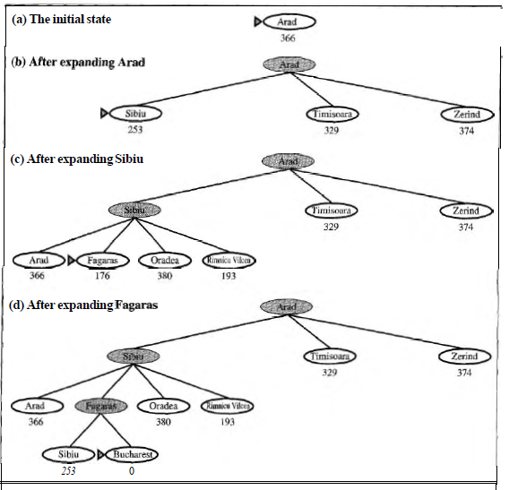

- Greedy best-first search using hSLD to find a path from Arad to Bucharest.
- The first node to be expanded from Arad will be Sibiu, because it is closer to Bucharest than either Zerind or Timisoara.
- The next node to be expanded will be Fagaras, because it is closest. Fagaras in turn generates Bucharest, which is the goal.
- Greedy best-first search using hSLD finds a solution without ever expanding a node that is not on the solution path; hence, its search cost is minimal.
- It is not optimal, however: the path via Sibiu and Fagaras to Bucharest is 32 kilometers longer than the path through Rimnicu Vilcea and Pitesti.

Properties of Best First Search:
- Complete: NO.
Heuristic puts every option path to be the best one. Heuristic that works reasonable wont get into problems.
- Optimal : NO,
The selection of minimum value of ‘h’.
Search could lead to dead ends.
- Time and space complexity:
Time: b^m, where m is the maximum depth reached.
Space : b^m

A* Algorithm
- Best first search is simplification of algorithm A*, where f(n)=h(n) and g(n)=0;
  - Where g(n) = sum of edge costs from start to h (n) = estimate of lowest cost path from n
  - f(n) = actual distance
  - h(n) is said to be admissible if it underestimate reached from n. If C*(n) is the cost of the cheapest a
  - h(n) <= C*(n). e can prove that if h(n) is admissible, then the search will find an optimum W
- The choice of an appropriate heuristic evaluation function, h(n), is still crucial to the behavior of this algorithm.
- In general, we want to choose a heuristic evaluation function h(n) which is as close as possible to the actual cost of getting to a goal state.
- If we can choose a function h(n) which never overestimates the actual cost of getting to the goal state, then we have a very useful property. Such a h(n) is said to be admissible.
- Best-first search is , where the agenda is sorted according to the function f(n) = g(n) + h(n) and where the function h(n) is admissible, can be proven to always find an optimal solution. This is known as Algorithm A*.

Algorithm:
- So now that you know how to compute the score of each square (we’ll call this F, which again is equal to G + H), let’s see how the A* algorithm works.
- The cat will find the shortest path by repeating the following steps:
- Get the square on the open list which has the lowest score. Let’s call this square S.
- Remove S from the open list and add S to the closed list.
- For each square T in S’s walkable adjacent tiles:
  - If T is in the closed list: Ignore it.
  - If T is not in the open list: Add it and compute its score.
  - If T is already in the open list: Check if the F score is lower when we use the current generated path to get there. If it is, update its score and update its parent as well.
Example:
Let us take the above discussed example of travel from Arad to Bucharest. The A* algorithm works as shown below:

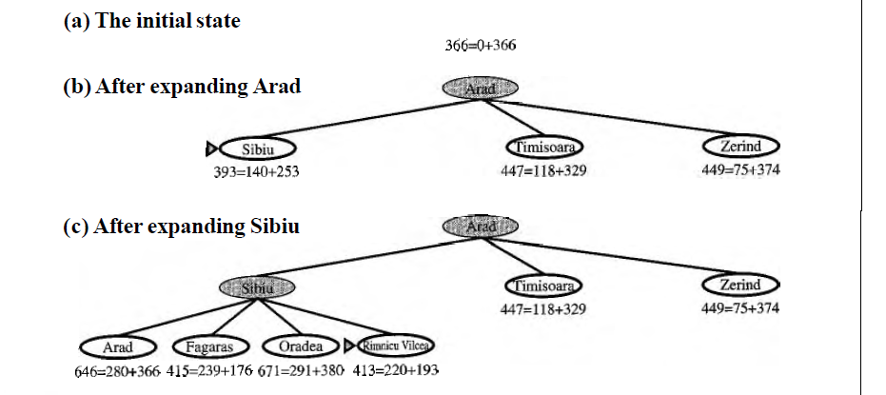

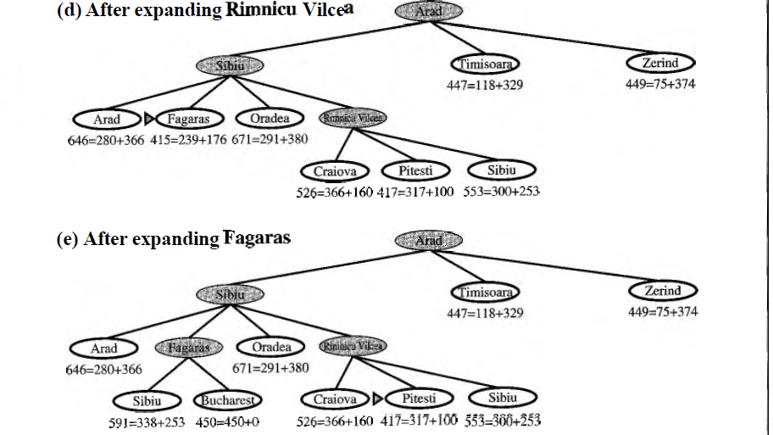

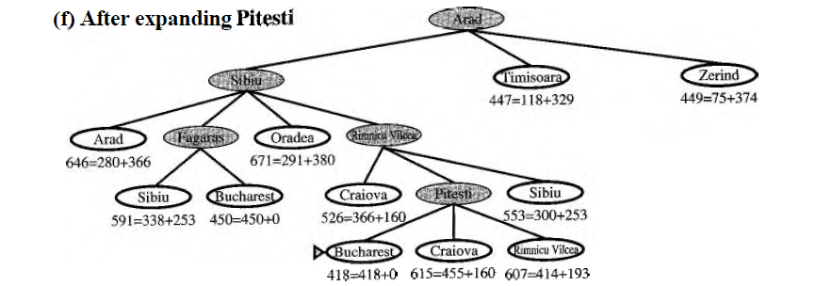

It can be said that A* gives us the optimal path that Best First Search failed to give.

Admissible heuristics
- Any search algorithm is admissible if it always produces an optimal solution.
Note: It means it finds optimal solution as the first solution. So cost is optimal.
- So for any node n, the heuristics h’(n) would be cost of optimal path of node n to the goal state.
- A heuristic h(n) is admissible if for all nodes n,
h(n) ≤ h*(n), where h*(n) is the true cost to reach the goal state from n.
- An admissible heuristic never overestimates the cost to reach the goal, i.e., it is optimistic
- Example: h_{SLD}(n) (never overestimates the actual road distance)

Optimality of A*
- Suppose some suboptimal goal G₂ has been generated and is in the fringe. Let n be an unexpanded node in the fringe such that n is on a shortest path to an optimal goal G.

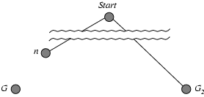

- f(G₂) = g(G₂) since h(G₂) = 0
- g(G₂) > g(G) since G₂ is suboptimal
- f(G) = g(G) since h(G) = 0
- f(G₂) > f(G) from above

- Suppose some suboptimal goal G₂ has been generated and is in the fringe. Let n be an unexpanded node in the fringe such that n is on a shortest path to an optimal goal G.
f(G₂) > f(G) from above
h(n) ≤ h*(n) since h is admissible
g(n) + h(n) ≤ g(n) + h*(n)
f(n) ≤ f(G)

Hence f(G₂) > f(n), and A* will never select G₂ for expansion
- A* expands nodes in order of increasing f value
- Gradually adds "f-contours" of nodes
- Contour i has all nodes with f=f_{i}, where f_{i} < f_{i+1}

Properties of A*
- Complete: Yes (unless there are infinitely many nodes with f ≤ f(G) )
- Optimal: Yes
- Time : Exponential , Computation time is not the constraint
- Space: Keeps all nodes in memory, A* might run out of space before it runs out of time.

- Test Methods
- Black box Testing
- White box testing
- Manual Testing & / or Unit testing

SR . NO | TEST CASE | EXPECTED OUTPUT | ACTUAL OUTPUT
1 | The heuristic values of the 2 non-visited node from current node are same | Next node randomly chosen which will give minimum distance to destination | Same as expected
2 | Heuristic distances of middle nodes between source and destination is greater than the heuristic distance between source and destination | Error in final path | Same as expected

- Conclusion:
Thus we have studied graph traversing method and implemented A* Algorithm of informed search methods.

